Courses

Courses are the spaces on Moodle where [teachers](https://docs.moodle.org/31/en/Teacher) add learning materials and activities for their students. Courses may be created by [admins](https://docs.moodle.org/31/en/Administrator), [course creators](https://docs.moodle.org/31/en/Course_creator) or [managers](https://docs.moodle.org/31/en/Manager). Teachers can then add the content and re-organise them according to their own needs.

# Module: Adding a new course

## Feature: Bulk course creation

This feature enables users to create several courses at once by defining them in a CSV file. For full details on how to bulk create courses and use course templates, see Module: [Upload courses](https://docs.moodle.org/31/en/Upload_courses).

# Module: Upload courses

## Feature: To upload one or more courses

1. Go to Administration > Site administration > Courses > Upload courses
2. Either drag and drop the CSV file or click the 'Choose a file' button and select the file in the file picker
3. Select appropriate import options carefully, and then click the preview button.

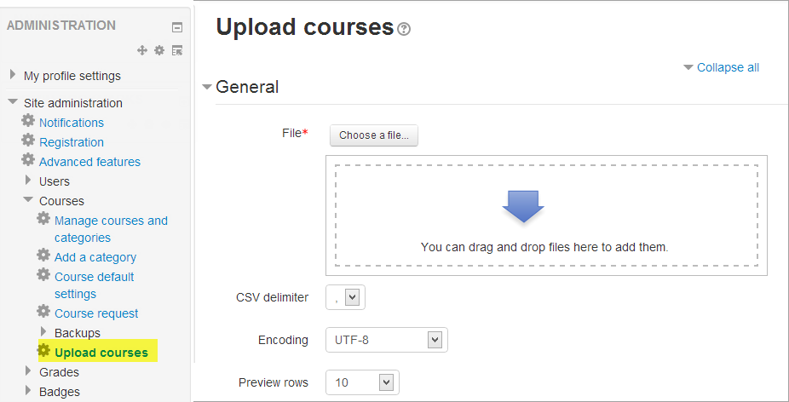

# Problem

Suppose you created a CSV file containing a list of new courses he wants to add in German language as shown in the figure below:

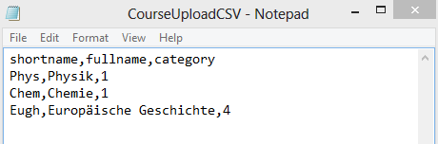

After you uploaded the CSV file, and you viewed the uploaded course results, the special German character “ä” is replaced with incorrect symbols “?”, such as in line 3 shown below:

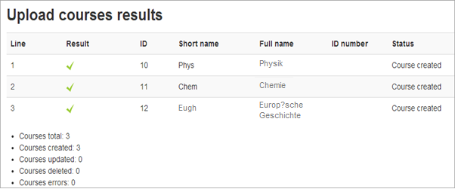

Write a feedback documenting that problem to the development team.